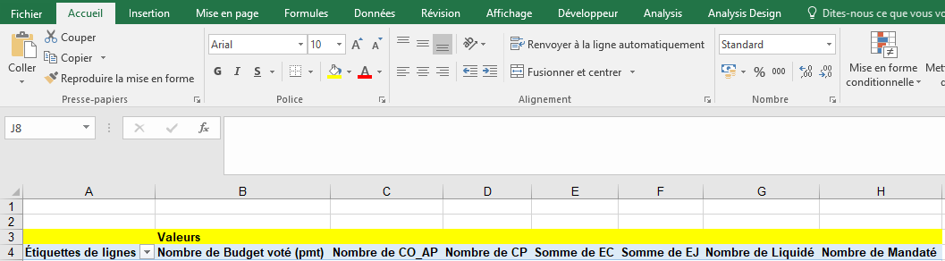

Sub Exe_BI_TCD()
Dim wsDepenses As Worksheet
Dim wsNewTCD As Worksheet
Dim pvtCache As PivotCache
Dim pvtTable As PivotTable
Dim lastRow As Long
Dim dataRange As String

' Affecter les feuilles de calcul aux variables
Set wsDepenses = Workbooks("Exé_BI_Suivi_CP_OP.xlsx").Sheets("Dépenses_CP_DF")

' Créer le TCD pour "Dépenses_CP_DF"
lastRow = wsDepenses.Cells(wsDepenses.Rows.Count, "J").End(xlUp).Row
dataRange = wsDepenses.Name & "!B2:J" & lastRow
Set wsNewTCD = Workbooks("Exé_BI_Suivi_CP_OP.xlsx").Sheets.Add(after:=wsDepenses)
wsNewTCD.Name = " Dépenses_CP_DF"
Set pvtCache = Workbooks("Exé_BI_Suivi_CP_OP.xlsx").PivotCaches.Create(SourceType:=xlDatabase, SourceData:=dataRange)
Set pvtTable = pvtCache.CreatePivotTable(TableDestination:=wsNewTCD.Cells(3, 1), TableName:=" Dépenses_CP_DF")
pvtTable.RowGrand = True

With pvtTable
.PivotFields(wsDepenses.Range("B2").Value).Orientation = xlRowField
.PivotFields(wsDepenses.Range("C2").Value).Orientation = xlRowField
.AddDataField .PivotFields(wsDepenses.Range("D2").Value)
.AddDataField .PivotFields(wsDepenses.Range("E2").Value)
.AddDataField .PivotFields(wsDepenses.Range("F2").Value)
.AddDataField .PivotFields(wsDepenses.Range("G2").Value)
.AddDataField .PivotFields(wsDepenses.Range("H2").Value)
.AddDataField .PivotFields(wsDepenses.Range("I2").Value)
.AddDataField .PivotFields(wsDepenses.Range("J2").Value)

End With

End Sub

